[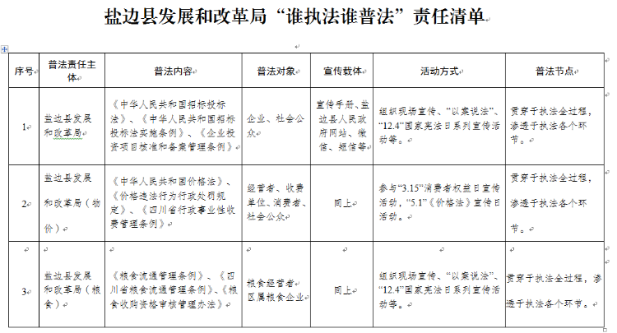](http://10.3.1.100:8099/uploadfiles/202001/03/2020010311335235098155.png)